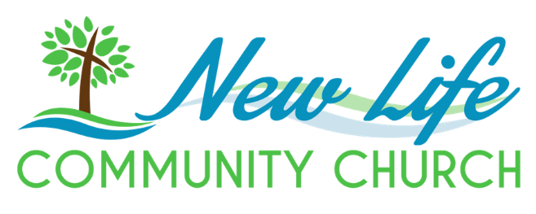 | Job Description  Associate Pastor
Are you enthusiastic about working with God’s people to see them develop and grow in their love for Jesus? If so, this job may be for you. We are looking for an individual who has a heart for evangelism and discipleship, and who senses the call to work alongside our Senior Pastor at New Life Community Church (NLCC) in Stony Plain, AB.
Approximately 125 people call NLCC their church home. NLCC is on a discipleship journey focusing on relationship over programs. Our Vision is to see “People in a life changing relationship with Jesus Christ, in a Spirit-filled, supportive, growing, family church, that serves our community and ourselves in a welcoming, engaging and responsive way.” If you think this is a vision God has equipped you to contribute to, please submit a cover letter addressed to “The NLCC Search Committee” and your resume to: AssociatePastorNLCCStony@gmail.com.
POSITION OVERVIEW
Guided by the Senior Pastor (Sr. Pastor), the Associate Pastor of New Life Community Church (NLCC) provides spiritual and pastoral leadership to NLCC congregants and the communities of Stony Plain and Parkland County. This includes leading by example, providing discipleship through preaching/teaching that is grounded in God’s Word, which includes equipping the congregation for various works of ministry such as evangelism and spiritual formation, and providing pastoral care in partnership with the Senior Pastor, Elders, and other Ministry Leaders (i.e. Worship, Small Groups).
RESPONSIBILITIES
Leading by example
- Maintain spiritual and personal well-being through regular bible reading and prayer,
- Maintain healthy relationships within and outside of the church,
- Maintain mentoring and coaching relationships for personal and spiritual development, and
- Seek help from the Sr. Pastor and Elders as needed.

Discipleship
- Preaching:
  - Responsible for preaching one to two times per month, and
  - Assists the Senior Pastor with developing a preaching calendar that incorporates other Elder-affirmed members of the congregation gifted in preaching/teaching.
- Evangelism:
  - Identifies opportunities to partner with other para-church ministries to further the gospel and encourages congregant engagement,
  - Supports NLCC’s Mission to follow God in making disciples who love and live for Jesus, and
  - Assists with equipping and encouraging the congregation to participate in evangelism efforts in our community.
- Spiritual Formation:
  - Identifies ministry opportunities/needs and engages the NLCC congregation to participate in meeting those needs,
  - Develops or sources materials for small group studies that are relevant to NLCC’s context,
  - Teaches small group studies and encourages application of lessons,
  - Assists Sr. Pastor with equipping church congregants to lead small group studies, and
  - Engages with NLCC online audience and works towards integration of viewers into the church body of believers.
Pastoral Care
- Inspires spiritual maturity in the NLCC congregation through personal example and connections to other spiritual leaders,
- Provides care for spiritual, emotional, and physical needs in partnership with the Sr. Pastor, Elders Board and other lay leaders,
- Administers communion to shut-ins outside of church services as needed,
- Identifies and resolves problems creatively,
- Visits hospitals to provide spiritual care to those in need,
- Offers minor counseling and refers individuals to professionals for extensive counseling, and
- Conducts baptisms, funerals, pre-marriage counseling, and weddings for NLCC congregants as required.
JOB REQUIREMENTS
Education
- Bachelor’s Degree in Pastoral Ministry or equivalent, or
- Currently enrolled in a ministry degree program,
AND
- Credentialed minister of the EMCC, or
- Willing to become a credentialed minister of the EMCC.
Skills & Competencies
- Sound Doctrine/Theology. Upholds biblically accurate beliefs aligned with historical Christian teachings, agrees with and promotes the EMCC Articles of Faith, and conducts oneself in a manner that fosters spiritual health within a Christian context.
- Visionary leadership. In partnership with the Sr. Pastor and church Elders, demonstrates sensitivity to the Holy Spirit’s leading in identifying community and church short- and long-term needs and improving church effectiveness.
- Nurturing relationships. Engages in the lives of others with love and compassion, prioritizing personal relationships with God and His people over traditional organizational, programmatic methods. Encourages healthy relationships within the church context using biblical principles to address conflict and promote servant leadership.
- People-minded ministries. Understands the NLCC community context and develops creative/innovative ways to engage congregants and the community in deepening their relationship with Jesus Christ and addressing community challenges.
- Ministry teamwork. Supports and equips ministry leaders, inviting and guiding people into meaningful roles that align with their spiritual gifting. Guides ministry leaders in fostering a collaborative environment that serves and supports the needs of the NLCC community.
- Communication. Works with the Sr. Pastor to establish direction, goals, and structures that support the Mission, Vision and Values of NLCC. Communicates effectively with NLCC leaders and congregants by utilizing various learning methods to engage multiple personality styles.
- Manage budget and resources. Comfortable in planning and managing financial resources within the boundaries established on an annual basis.
- Organization. Ability to prioritize and manage time and resources.

Other
- This position is 30 hours per week and offers health benefits.
- Must become a member of NLCC.
- This position is designed to prepare the incumbent for potential future leadership opportunities within NLCC.

